GULISTAN & TURGUT OZAL EDUCATIONAL INSTITUTIONS
INFORMATICS LESSON PLAN

DATE :
DURATION : | 40 minutes
GRADE LEVEL: | 10th Class
SUBJECT : | Validating Data
OBJECTIVES : | To understand and to be able to manage Information Lists

LESSON PLAN
Key words:
Materials used: | Microsoft Excel 2003 Book, Computer
Warm-up questions:

Introduction and explanation of the lesson;
DATA VALIDATION
You can help users to enter accurate and appropriate information into worksheets with Excel’s Data Validation feature. Data validation can restrict the type of information that is entered in a cell and can provide the user with instructions on entering information.
Example: To improve the worksheet, restrict the data entrance into the table below. Because the school uses a 10-grade system, so you should be able to enter only decimal numbers between 1 and 10.
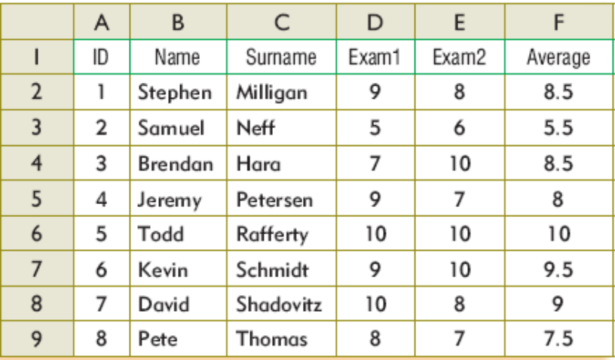
Analyses and Solution
Before you open the Data Validation dialog window, you must select the range of cells to which you want to apply validation. Select the range D2:E9 range. Now you can open Data Validation from the Data menu. In the Settings tab of the Validation dialog box, you can enter validation criteria. You can choose the type of data that you want to enter in your selected area from the Allow drop down menu. For this example, select Decimal type. From the Data drop down menu you can select conditional criteria for your selected range. You can enter the range of the values, depending on the conditional criteria that you selected in the data drop down menu. Set the minimum value to 1 and maximum value to 10.
Input Message:
You can enter a title and an input message that will be displayed when you select any cell(s) in the selected range. If you clear the check box Input Message will be disabled.
Error Alert:
You can also enter a title and an error message that will be displayed when someone enters an incorrect value which you restricted from your settings.
There are three options; Stop, Warning, and Information in the Style drop down menu.
 Stop: Prevents you from entering an incorrect value.
 Warning and Information: displays the error message and asks if you are sure or not. If you say
OK, it’ll accept the value.
If you clear the check box at the top, the error alert will be disabled.

CONCLUSION:

HOMEWORK:

Teacher Director

